Advance Care Planning – Don’t Leave it Too Late
Advance Care Planning is the process of thinking, planning and documenting your choices so you can live well right up to the end of life.
This storyboard is designed to explain why advance care planning is important. It includes information about the steps you should take to ensure your wishes are known by both your family, carers and any health professionals.
Frame 1: When it comes to the end of our lives it is still important that our wishes for how we live our lives, including choices around dying, are known, heard and respected.
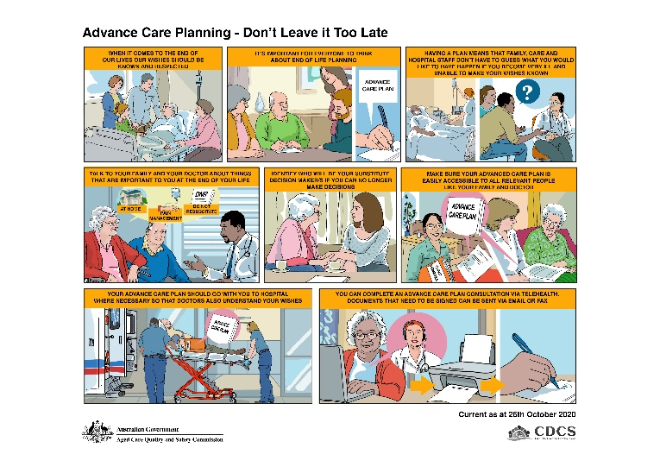
Frame 2: Advance care planning is not just for people who are in palliative care, it’s for everyone. This is important because we don’t know when or if we will be in a situation where we are unable to express our choices.
Frame 3: Having a plan means that your family, those who support you and hospital staff don’t have to guess what you would like to happen should you become unwell or if you are in a position where you are unable to make your wishes known.
Frame 4: Talk to your family and other loved ones, along with your doctor about things that are important to you at the end of your life. This might include where you prefer to palliate, what sort of life saving interventions you are happy to accept or perhaps what ‘last rights’ are important for you to receive.
Frame 5: It’s important for you to identify who will be your substitute decision maker/s in the event you are no longer able to make decisions. Make sure that you have a conversation with them about being your substitute decision maker and that they have access to a copy of your advance care plan.
If you want to, your advance care plan can be formalised through an advance care directive. An advance care directive is a type of written advance care plan. As part of an advance care directive you can formally appoint a substitute decision-maker.
Frame 6: It’s important to ensure your advance care plan is easily accessible to all relevant people, such as family members, your care provider and your Doctor.
Frame 7: If you need to visit hospital, take a copy of your advance care plan with you and give this to the intake staff member.
Frame 8: If you are not able to visit your GP in person you can complete an advance care planning consultation via telehealth. Documents can be completed and sent to you via email or fax for signing.

