Aged Care Quality Standards
Storyboard user guide

May 2020

Contents

Overview 3
The Aged Care Quality Standards: Summary 4
Standard 1: Consumer dignity and choice 6
Standard 2: Ongoing assessment and care planning 7
Standard 3: Personal and clinical care 8
Standard 4: Services and supports for daily living 9
Standard 5: Organisation’s service environment 10
Standard 6: Feedback and complaints 11
Standard 7: Human resources 12
Standard 8: Organisational governance 13
Key concept: Dignity of risk 14
Key concept: Open disclosure 15

Overview
This guide has been developed to accompany the Aged Care Standards Storyboards. It can be used to assist facilitators when using the Storyboards in training sessions or to provide more detailed understanding of the context for each story.
What are the Aged Care Quality Standards Storyboards?
The Aged Care Quality Standards Storyboards are illustrated scenarios designed to provide a pictorial representation of how each of the Standards apply. They have been developed for a rural and remote context to assist consumers, staff and other people interacting with aged care services to understand better, the application of the Aged Care Quality Standards in a day to day context.
The following pages explain for each Storyboard:
- the background to the Standard or concept; and
- the narrative of the story being conveyed in the visual Storyboard to assist the facilitator in understanding and providing further explanation to others where this is required.
Other Information
It is recommended that facilitators also refer to the ‘Guidance and Resources for Providers to support the Aged Care Quality Standards’ manual produced by the Aged Care Quality and Safety Commission. The Guidance and Resources describes each of the Standards in more detail and provides actions and examples for each of the Standards.

You will find the latest version of the above manual and further resources on the Commission’s website: agedcarequality.gov. au/providers/standards
Acknowledgment
We thank all the organisations and individuals who provided valuable feedback during the development of these Storyboards, your contribution has really helped to shape the final versions of the scenarios and graphics used.
Prepared on behalf of the Australian Aged Care Quality and Safety Commission by Culturally Directed Care Solutions (CDCS Pty Ltd).

Disclaimer
While the Storyboards relate to scenarios in remote settings, the stories in no way reflect any individual identifiable incident. The images used in this guide and the Storyboards are artist representations only
and are not intended in any way to represent any person, living or deceased.
Copyright
Please refer to the Commission’s website for further information: agedcarequality.gov.au/copyright

The Aged Care Quality Standards: Summary
The Aged Care Quality Standards are summarised in this storyboard. This may be helpful as you discuss the Quality Standards in your organisation with both staff and consumers.
Storyboard scenario: Standards summary
Introduction
The coordinator is sitting with a consumer named Suzie. Suzie is a new consumer with the service and the coordinator wants to make sure Suzie understands what the Standards mean for her.
The organisation has included the Standards wheel in their Client Handbook so that consumers are aware of these. The coordinator is showing the Standards Wheel
to Suzie and explaining how these will impact on Suzie’s care.

Standard 1: Consumer Dignity and choice
The coordinator points out that what is important to Suzie will be respected.
Suzie thinks about the things that are important to her, her culture and the activities that she likes to do.

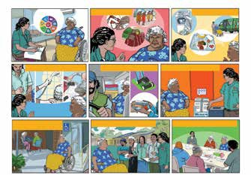
ORGANISATIONAL GOVERNANCE
HUMAN RESOURCES
ORGANISATION SERVICE ENVIRONMENT
FEEDBACK AND COMPLAINTS
Come
and have a yarn !
We want to know how we can make things better for you
SUPPORT FOR DAILY LIVING
PERSONAL AND CLINICAL CARE
ONGOING ASSESSMENT

I NEED HELP
our Standards
DIGNITY AND CHOICE
The Aged Care Quality Standards
These are

Standard 2: Ongoing assessment and planning with the consumer
When the coordinator discusses Standard Two, Suzie points out that she needs meals delivered because she doesn’t have a stove that works. She also tells the coordinator that she can’t put clothes in the machine because she is in a chair and she wants help to
go to activities.

Standard 3: Personal and clinical care
Suzie and the coordinator talk about her personal care needs, such as help with showering from a support worker; help from a nurse for her diabetes insulin injection; and assistance from a podiatrist with foot care.
The coordinator discusses how the people who provide this help will have the right skills and training to do these tasks.

Standard 4:
Services and supports for daily living
When they discuss Standard Four, Suzie thinks about the sort of help that she needs to get under this Standard. The coordinator lets Suzie know that they will make sure this care is coordinated so that she gets good care, even though some of her support will come from a contractor.
Standard 5:
Organisation service environment
Suzie wheels herself outside through a sliding doorway that is wheelchair accessible to a group of friends who are sitting outside under a shade area. She notices there are plants and local art work on the walls and clear signs for the wheel chair accessible toilet. Suzie remembers the coordinator talking to her about how they want the centre to feel comfortable for everyone who visits and encouraged her to make any suggestions that could improve the centre.
Standard 6: Feedback and complaints
Suzie and the coordinator are standing/ sitting in front of a poster on the wall and the coordinator is reminding Suzie that she can make a complaint. She points out where the complaint forms are and shows Suzie that there is box where she can place an anonymous complaint if she wants to.
Standard 7: Human resources
Suzie also remembers how she was introduced to the people who worked at the centre. This included the support workers and nurse, as well as the cooks in the kitchen who prepare the meals on wheels and the activities bus driver. She feels safe knowing the staff are qualified to provide her support and that they were all friendly and welcoming towards her.
Standard 8: Organisational governance
Suzie is also invited to be a consumer representative on the local advisory group who provide feedback and suggestions to the Board. Suzie takes up this offer and feels satisfied that she is contributing to making the aged care service even better.

Standard 1:
Consumer dignity and choice
“I am treated with dignity and respect and can maintain my identity. I can make
informed choices about my care and services, and live the life I choose.”
This Standard focuses on the consumer
as an individual with goals, plans and desires as well as understanding and recognising that they may have specific preferences about how care and support is delivered.
Informed choice means providing a person with all the relevant information about
a course of action so that they can weigh up the pros and cons of their action.
To help a person really understand what
is being discussed the information needs to be presented in a way that they understand.
Storyboard scenario:
Helping Lena to make choices
Frame 1: Lena is an old lady who doesn’t speak English very well she has been referred to the organisation for services.
Frames 2-4: When the coordinator goes
to visit Lena, and conduct the assessment, she realises that they aren’t communicating well. To help overcome this challenge she finds a support worker who can speak Lena’s language and also understands the aged care program.
Frames 5-6: Using the support worker as an interpreter, she asks Lena what makes her happy and what gives her life meaning. Lena explains through the interpreter that she likes fishing, spending time talking with family, going for drives in the troop carrier to look
at the land and weaving mats.

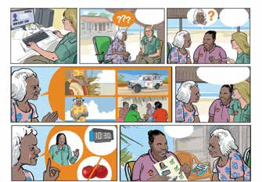
A.M.
Female
Your care plan
What is important for us to know
when providing care?
What makes you happy?
What makes you happy?
Standard 1: Consumer dignity and choice

The Coordinator asks “what is important for us to know when providing care?” (she wants to know what the service need to know about Lena’s likes, dislikes and preferences).
Lena explains that she would like to have
a female support worker to help her, that she doesn’t like to have her services too early
in the morning (around 10:30am is good for her). She also explains that she doesn’t like tomatoes.
Frame 7: Finally, the coordinator creates a pictorial care plan. The support worker
discusses this with Lena as well as giving her a Client Handbook that has been developed to meet the needs of the consumers
of the service. This helps to ensure that Lena understands the care and support she is getting and can actively contribute to developing her care plan.

Standard 2:
Ongoing assessment and care planning
“I am a partner in ongoing assessment and planning that helps me get the care and services I need for my health and well-being.”
JANIE’S
MEAL PLAN
All care planning needs to be done with the consumer. They are very much at the centre of the planning phase of care and support.
Storyboard scenario:
Helping Janie to live well at home
Frame 1: Janie has recently returned to her home community where she used to receive basic care support however, she is now on dialysis to manage kidney failure.
Janie is finding some things are more difficult in her life now, which means her services need to be reviewed and some changes made to help her live a better life.
Janie meets with the aged care coordinator to talk about what could be changed to better meet her needs. Janie talks about how she gets tired, but also bored from her new dialysis regime. She is confused about what
she needs to eat and is often feeling too tired to cook all her meals
Frames 2: The coordinator notes that Janie also needs to have her blankets washed regularly to make sure she doesn’t pick up infections. Janie is finding it difficult to wash the heavy blankets when she is tired.
The coordinator consults with other specialists after talking to Janie and reading her updated plan from the Allied Health team. She sends through referrals to relevant people and organisations as part of planning Janie’s care, one of these is to a dietitian.

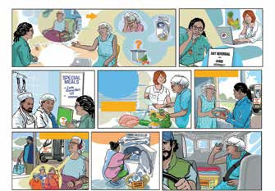
Frame 3: The coordinator speaks with the kitchen staff about Janie’s dietary needs and provides them with a meal plan to help prepare suitable meals for Janie.
MEALS AT DIALYSIS CENTRE
DIETARY ADVICE

BETTER FOOD CHOICES
MEALS AT HOME
DIETITIAN
What to cook?
What would make your life better?
Standard 2: Ongoing assessment and planning with consumers

DIALYSIS

Tired and bored

Help!
Frame 4: Janie meets with the dietitian as part of her care support, the dietitian works with Janie to help her understand the food choices and the sort of meals she should be eating to support her dialysis treatment.
Frames 5-8: To make sure that Janie has at least one good meal each day the aged care service arranges for a meal to be delivered either to the dialysis centre or to Janie’s home, depending on where she is that day. The coordinator also found out that Janie likes to listen to music sung by the local women’s choir while she is on dialysis, so
a CD player and some music was purchased by the service. These remain at the dialysis centre so that Janie can enjoy them when undergoing her treatment. The aged care service also works collaboratively with the dialysis clinic on the community, dropping Janie home along with her freshly washed blankets after her dialysis treatment.

Standard 3:
Personal and clinical care
“I get personal care, clinical care, or both personal and clinical care, that is safe and right for me.”
Personal care and clinical care should
be delivered by staff who are trained and understand how to provide the right care and support for the consumer.
One of the important aspects of clinical care is supporting infection control and
encouraging good anti-microbial stewardship (AMS). AMS means helping the consumer
to finish taking their course of antibiotics to minimise the risk of microorganisms gaining resistance in the wider community.
Storyboard scenario: The right personal and clinical care for Eric
Frames 1-2: Eric, an elderly Torres Strait Islander man had been in a minor car accident and as a result had ended up with ulcers on his leg that were taking time
to heal. His doctor has prescribed antibiotics to help clear up the infection and Eric is having the wound cleaned and dressed daily by the RN from the health centre.
Frame 3: Eric’s local aged care service receive a referral to assist Eric with medication prompting, personal care and transport to the health centre to get his wound dressed.

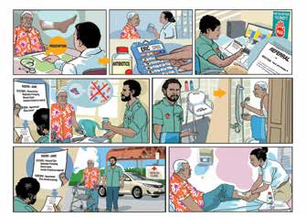

Standard 3: Personal and clinical care

Frames 4-5: A male support worker, Max, is assigned to assist Eric. Max has been trained in personal care and how to assist
a person with medications. He reminds Eric to take his medications explaining to Eric that if he doesn’t take them the germs in his leg may become resistant to the antibiotics and make it harder to clear up.
Frame 6: Eric only needs some assistance
to get his shower ready and to dry his feet off after showering. Max helps Eric only with the tasks listed on the care plan, knowing that it is better for Eric to remain independent and respecting his privacy.
Frame 7: After assisting Eric with his showering, Max drives Eric to the clinic
to have his wound dressed. Eric is encouraged to use a walking frame to walk into the health centre rather than a wheelchair. This helps with his rehabilitation and keeps him active.
Frame 8: At the local health centre, a nurse checks and re-dresses Eric’s wound.

Standard 4: Services and supports for daily living
“I get the services and supports for daily living that are important for my health and well-being and that enable me to do the things I want to do.”
Services and supports for daily living are not just about cleaning someone’s house or providing a meal. They’re there to help the person to do things that are important
to them, that improve their quality of life and help them to stay safe and remain a part
of their community.
Coordination of supports including those provided by contracted suppliers is an important part of ensuring that consumers receive the care and support in a timely manner and in a way that enhances their overall well-being.
Storyboard scenario: Jeffery’s garden
Frames 1-4: Jeffery is an old man who lives alone. One of the support workers who assists Jeffery in his activities of daily living notices that his yard has become messy and there is very long grass. The support worker is concerned that this is a hazard for Jeffery.
The support worker talks with Jeffery about this and takes their concerns back to the coordinator. This initiates a review of Jeffery’s needs and the coordinator goes to visit him in his home.

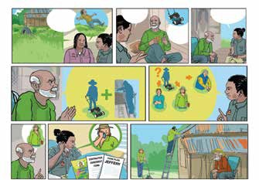
I choose Tabitha
Service Care
Garden
Mowing
1 2
James’ Tabitha’s
3
Pete’s Garden Service
We can refer you to
someone who can help
What I really need help with
JEFFERY’S GARDEN
My knee is sore from arthritis
What would help you?
HELP
What’s the problem?
I’m worried about uncle Jeffery
BROKEN
Standard 4: Services and supports for daily living

The coordinator and Jeffery discuss the problem and the coordinator learns that Jeffery’s lawn mower is broken and this, combined with his arthritis means he can’t mow his grass anymore. He also mentions that the leaves are building up in his roof gutters and are a fire hazard with the approaching summer season.
Frames 5-6: Although the organisation doesn’t provide a lawn mowing and home maintenance service the coordinator can arrange with a contractor to provide the service for Jeffery. She arranges quotes from three different contractors and provides this information to Jeffery, giving him the opportunity to make the choice of who will provide the service.
Frames 7-8: Once Jeffery has made his choice, the coordinator liaises with the preferred supplier and coordinates the support so
that Jeffery receives the help he needs in a timely manner.

Standard 5: Organisation’s service environment
“I feel I belong and I am safe and comfortable in the organisation’s service environment.”
It is important that organisations recognise that the service environment is important in providing a safe and welcoming space for
consumers. This includes not only the service centres used in residential care, but centres used for day respite and vehicles used to deliver services such as the transport buses and cars. Note: the service environment does not include an individual consumer’s home.
Storyboard scenario: Improving the service environment
Frame 1: The coordinator of the aged care service has called a consumer meeting where he asks for ideas for making the centre better for the people who use it.
These are the issues and solutions depicted through the rest of the storyboard:
Frames 2-8: The centre is very bland and there is no local cultural input evident. The wall and floor colour are both light. There is no contrast between them which makes it difficult for people who have low vision or dementia. There are also no exit signs to
assist people to know which door to go out if there was an emergency. The group suggest adding local artwork and more comfortable seating. An exit sign is added to the relevant doorway making the centre safer.
The group note that the outside area is not used much and suggest adding a shade structure, along with some comfortable furniture and plants. They also request a space where people can sit that is screened away from other consumers. These changes will improve the comfort for consumers; acknowledge cultural differences; and provide a more welcoming environment.

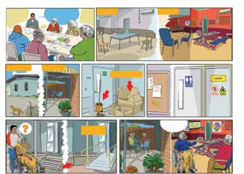
EASY ACCESS
This is now a better place
REMOVE CLUTTER
COMFORTABLE
HOT AND DUSTY
AFTER
Standard 5: Organisation’s service environment
What would make this BEFORE
place better for you?

An audit by the coordinator also noted that cardboard boxes were being piled up against an exit doorway and staff had left a bucket and mop leaning against the door. He realises that this is a hazard and notes that staff need to dispose of rubbish and return cleaning items after use.
The consumer group also ask for better signage at the centre so that visitors know where the toilets are and what areas they can or can’t go. They also request a noticeboard so that they can read important notices. They say that this will make it less confusing for people using the centre.
One consumer speaks up about the entrance to the centre, it has a couple of steps which makes it hard for people in a wheelchair
or who use a wheelie walker to access the building. He suggests this is changed
to a ramp to make the centre more accessible for everyone.
The changes that are made by the service help the consumers using the centre to feel at home. The building is now bright and inviting with comfortable chairs, local artwork and a garden. The building is also now accessible for those with mobility issues.

Standard 6:
Feedback and complaints
“I feel safe and am encouraged and supported to give feedback and make complaints. I am engaged in processes to address my feedback and complaints, and appropriate action is taken”.
Getting feedback and handling complaints appropriately is an important part of making sure that the services and supports that are provided to consumers are appropriate and meet their needs. It is also important that consumers feel their voice is heard.
Storyboard scenario: Understanding and dealing with complaints
Frame 1: The aged care service wants to make sure that staff, consumers and their representatives are aware of what
to do when things don’t go right. The service holds a training session on Feedback and Complaints for care staff.
Frames 2-3: The organisation also has a Client Handbook that includes the complaints process, this is provided to every consumer, so they understand how to make a complaint.
The centre also ensures that consumers who use the centre know that there are other people who can help them if they need an advocate when making a complaint. One way they do this is by posting relevant materials on the notice board in the centre.
Frame 4: Generally, if a person needs help with translation they can access the Translation and Interpreting service (TIS).
However, as there are very few indigenous language speakers in this service it is more likely they will use a local interpreter

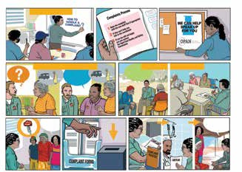
Sorry about your meals, we’ve fixed the problem
Mum needs softer food
What do you think we can do better?
CLIENT MEETING
SURVEY
DEALING WITH THE LANGUAGE BARRIER

No one picked up Molly for the outing
Standard 6: Feedback and complaints
STAFF TRAINING

who may be a support worker from the community. Using a translator means that staff from outside the immediate community understand clearly the issue and can address this appropriately.
Frames 5-6: The service gathers feedback in a number of ways including individual consumer surveys as well as meetings with the consumer group to find out how they can improve.
Frames 7-11:
The complaints process in action
A consumer accompanied by her family approaches one of the care staff because she has been given the wrong meal. The consumer’s preferences and requirements have been written up previously in her care plan. The staff member directs the carer and consumer to the complaints form and informs the coordinator. The coordinator reviews the complaint, talks to the kitchen staff and reminds them of the consumer’s requirements. She also visits the consumer
and carer to apologise and let them know the issue has been addressed.

Standard 7: Human resources
“I get quality care and services when I need them from people who are knowledgeable, capable and caring.”
Aged Care services need to make sure that the people who provide care and support to consumers are a right fit. This means the organisation needs to take into
consideration any preferences the consumer has around their care delivery as well as specific requirements for qualifications, skills and experience.
Storyboard scenario: Finding the right person to help Bessie
Frames 1-2: The aged care service has just received a referral for a new consumer who has special needs. The consumer, Bessie, would like a female staff member to help her with personal care. She also uses an oxygen machine to help her breathing.
After reviewing the current roster,
the coordinator realises they will need to employ a new staff member to meet
Bessie’s needs. Because they want to employ a local person who will understand Bessie’s cultural background better, they place an advert on the local Council noticeboard as well as in the local paper.
Erin has recently returned to the community and sees the advert for a support worker
on the noticeboard. She has previously worked as a support worker and submits an application.
Frames 3-4: The coordinator interviews Erin for the job. She reviews copies of Erin’s
CV, qualifications and references and after deciding that Erin would be suitable the Coordinator also applies for a Police Check for her.

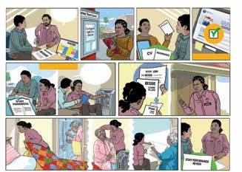

Standard 7: Human resources
we need to employ
another female support worker

POLICE CHECK

ORIENTATION AND TRAINING
This is how you use the
oxygen machine

Frames 5-7: Erin is employed to work with the organisation and is provided with an orientation which covers organisational requirements and information. She is also sent to learn how to help someone using a home oxygen concentrator. Erin is now ready to start work and receives her roster
and relevant information about Bessie. Erin arrives to care for Bessie. She is wearing her uniform and a name badge. She knocks on the door.
Frame 8: Erin assists Bessie according to the information in her care plan, making Bessie’s bed while Bessie has a shower. She then helps Bessie with the oxygen prongs and spends time with her, learning more about Bessie’s life over a cup of tea.
Frame 9: Erin regularly meets with her supervisor to discuss any issues she is facing and has a probation review after she has been working at the service for a couple
of months. This is followed up with an annual performance review and responsive
support and supervision form the coordinator as needed.

Standard 8:
Organisational governance
“I am confident the organisation is well run.
I can partner in improving the delivery of care and services. The organisations’ governing body is accountable for the delivery of safe and quality care and services.”
Consumers should feel they are a partner
in the development of the aged care service. This doesn’t mean they are involved in the day to day operation of the service but
that they are able to have input into ways of making the service better for all aged care consumers.
There are a number of aspects that make
up good organisational governance including having a Board that actively works towards developing the service, consultation with
the end users when planning service development work, having good processes in place such as staff meetings, disaster management plans, security of information, risk management processes and good financial management.
Storyboard scenario: A well run organisation takes planning
Frame 1: The Board of an aged care service are receiving information on the aged care program, they are reviewing the ‘Aged Care Report’ as well as a ‘Client Feedback Report’. They are meeting to discuss the Aged Care Strategic Direction for the next.
Frame 2: The organisation is building a new aged care centre and the builder is consulting with the coordinator and a group of Elders about the new building.
Frame 3: Staff and management meetings are important, they keep everyone informed about what is happening in the service.

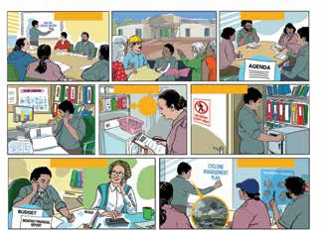
PLANNING SESSION
BUDGET MANAGEMENT
SAFETY SHEETS
MANAGEMENT OF SENSITIVE INFORMATION
SAFETY AUDIT
STAFF MEETING
Standard 8: Organisational governance
BOARD MEETING

To make sure that nothing important
is missed they follow an agenda and one of the staff writes up minutes.
Frames 4-6: As well as making sure the service runs smoothly and according to the vision of the Board, the aged care coordinator makes sure that all the essential paperwork for the service is maintained. This includes updating Registers, Policies and Procedures, Emergency Plans, Training plans, Work Health and Safety registers and documents as well as documenting any feedback and the results of complaints investigations.
In this organisation they make sure that things are safe for both staff and consumers by regularly conducting audits and following up with remedial action when they identify issues. These audits are good for planning future repairs, maintenance or improvements.
Frames 7-8: The coordinator regularly meets with the organisation’s financial
manager, making sure that they are adhering to budgets and that there are no financial issues. The coordinator also makes sure
that staff are consulted and are involved in the planning of emergency responses to foreseeable adverse events.

Key concept: Dignity of risk
Dignity of Risk is a term that means respecting a person’s wishes and preferences regarding the risks they choose to take.
The aged care provider is expected to help consumers to think about the activity or action a consumer wants to take and understand the associated risk as well
as helping work through options on how risk can be managed.
Providers are expected to show how they involve consumers and look for solutions that are the least restrictive of their choice and independence.
Dignity of Risk is a key aspect of Standard 1: Consumer Dignity and Choice.
Storyboard scenario: Judith’s story
Frame 1: Judith is sitting next to a small fire out the front of her home. She has a billy can on the fire and she is mixing up some damper in a dish next to her with her hands that she will cook on the ashes.
Frame 2: Judith is in the background sitting next to her fire. A family member is talking to a local support worker.
A family member talking to the support worker and saying, ‘I’m worried about mum and that fire, it’s too dangerous’.
Frame 3: The support worker is talking to Judith, explaining that there is a risk she could get hurt by the fire.

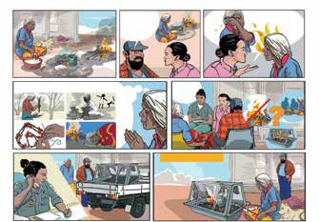
LIVING THE LIFE I CHOOSE
A frame?
Someone with me?
How can we help?
What fire does for me
You could get hurt
I’m worried about mum and that fire, it’s too dangerous
Dignity of risk: Judith’s story

Frame 4: Judith explains that fire helps her remember old days, keeps her active picking up wood, allows her to create art
work (burning holes in seed pods to create necklaces) and keeps her warm as she sleeps by the fire.
Frame 5: A staff, consumer and family carer meeting is held where this issue is discussed, and people come up with different ideas –
e.g. no fires at all; fire but only when other people are around; through to a frame over the fire. Judith as the consumer is involved and is supported by family in making
a decision.
Frame 6: The Manager is on the phone discussing an order for the construction of a safety frame to go over the fire pit.
A supplier delivers the safety frame to Judith’s home.
Frame 7: Judith now has a safety frame over the fire and you can see her and her family carer are happy with the outcome.

Key concept: Open disclosure
Open Disclosure is the open discussion of an incident that has resulted in harm, potential harm or an adverse outcome to
a consumer while receiving care and support from the Aged Care service with the consumer, their family, carers and other support persons.
Open Disclosure includes how the organisation recognises and acknowledges when something has gone wrong that could harm, or has harmed, someone.
The organisation is expected to talk to the consumer about this, apologise, and explain what has happened. They should also explain why it happened and what they are doing
to prevent it from happening again.
Open Disclosure is a key aspect of Standard 8: Organisational Governance.
Storyboard scenario: Malcolm’s story
Frame 1: The Aged Care service has planned an excursion to the local waterhole for their consumers, they need to take two vehicles to transport everyone, including staff to the location. After lunch Malcolm, who has
dementia and finds the large crowd too noisy heads over to a shady tree to rest and enjoy the view.
Frames 2–3: Staff, busy with other consumers are unaware that Malcolm has wandered off and start packing up at the end of the day.
They assist consumers to re-board the buses and as there are two vehicles the drivers don’t notice that Malcolm is not with them until they arrive back at the community.

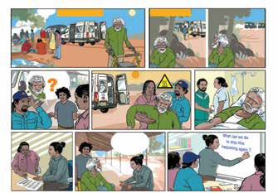
Sorry, we left you
behind
Where’s Malcolm?
PACKING UP
Open disclosure: Malcolm’s story
AGED CARE OUTING

Frames 4–6: The support workers return
to look for Malcolm and find him sitting down on the ground, with the sun beating down
on him. Malcolm is dehydrated and confused. The staff take him straight to the clinic where he requires an intravenous drip to assist
his recovery.
Frames 7-8: One of the support workers completes an incident form and the Coordinator meets with them to discuss how and why the incident occurred.
The Coordinator then goes to visit Malcolm and his family to talk about the incident and apologise.
Frame 9: The Coordinator holds a staff meeting and using the information in the incident form and an open no-fault discussion, they work together to identify ways to make sure that this sort of incident doesn’t happen again.

