Minimising Restraint in Home Services
The ‘Minimising Restraint in the Home’ storyboard and explainer is intended be used to start conversations within your service about what constitutes restraint, the impact of restraint and ways the use of restraint in the home can be minimised.
In addition to this storyboard resource, we encourage you to access the more detailed information available on the Commission’s website: https://www.agedcarequality.gov.au/resources/minimising-use-restraints-resources

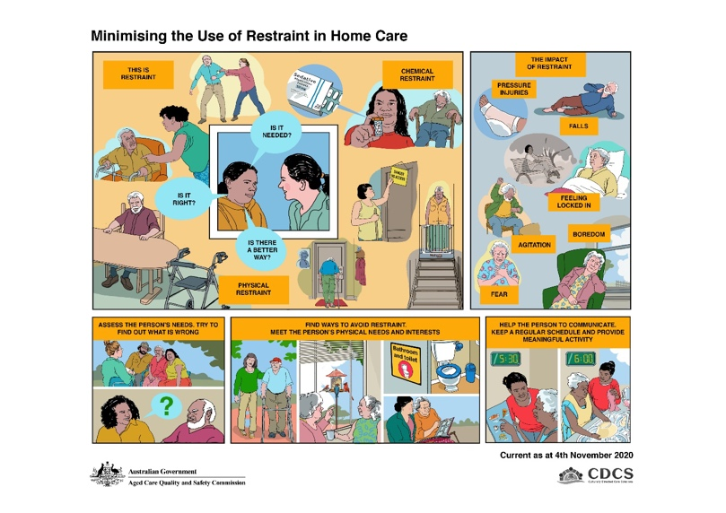
Restraint means any practice, device or action that interferes with a consumer’s ability to make a decision or restricts a consumer’s free movement. A restraint free approach should be seen as a basic human right for all aged care consumers as the use of restraints could infringe on a person’s right to freedom and dignity of choice. Restraints should only be used as a last resort, after all alternate strategies have been tried and following discussion with the person, their substitute decision maker and their doctor.
Frame 1: To minimise the use of restraint, it is important to understand and recognise what restraint is. To understand whether something is restraint, consider the following questions:
- Does this restrict the free movement of a person?
- Does this impede the free will of a person or their ability to make a decision (by affecting the way they think, feel, act, move)?
- Is this applied/administered to affect or change behaviour?
Below are some examples of different types of restraint. This list is not exhaustive:
Physical Restraint
- Holding onto a person to stop them going somewhere or holding a person down
- Using fixed bed rails or a lowered bed that makes it difficult for someone to easily get out
- Placing a table in front of a person that makes it difficult for them to get out of a chair and move around freely
- Moving essential mobility aids out of the person’s reach
- Installing keypads or safety gates that the person cannot easily open
- Locking a door to stop a person accessing a space.
There are also examples of ‘extreme’ restraints which are not condoned in aged care. These may include:
- Locking the person in their room or home
- Withholding access to personal items such as a mobile phone or TV programs
- Limiting access to food, cigarettes or drink.
Chemical Restraint
- Where medicine is used to sedate or restrict the movement of a person instead of for the treatment of a diagnosed health condition.
Frame 2 (inset): Family carers, aged care and health support staff should always think about whether what they are doing is right, if it is actually needed and whether there is a better way to do something that might be considered as restraint. Aged care or health support staff should discuss options with the family carer to see if there is a better way.
Frame 3: The use of restraint can harm the consumer. For example:
- the inappropriate use of medication - chemical restraint - can cause symptoms and may make behaviours worse. This can lead to a person becoming less independent, disorientated and falling over.
- having a fixed bed rail in place - physical restraint - can cause injury if the consumer tries to climb over or around the rail and becomes trapped.
- any sort of restraint that causes a consumer to remain confined to their bed or chair can lead to pressure injuries, loss of mobility, boredom and/or depression.
- Some people who have previously been in care (people who have been institutionalised at some time in their life) can experience flashbacks and feelings of re-institutionalisation, panic and lack of control over their lives.
- People who are restrained may suffer a psychological injury or become physically agitated. This could lead to them being injured, hurting another person or damaging property.
Frame 4: To minimise the use of restraint it is important to firstly know and understand the background, likes, dislikes, wishes and needs of each person. Spending time with the person and finding out what they like and want, will help you learn how to anticipate and meet their needs. Making a detailed assessment will help you to understand any triggers of behaviour and anything which may be calming.
Where any form of restraint is considered, even where the consumer or their family requests the use of restraint for the purpose of safety and security, it is important that this is discussed with the person, their substitute decision maker, their Doctor, and where appropriate their significant others. People often don’t understand the potential harms. Alternatives to restraint should always be tried with restraint only used as a last resort.
Any restraints approved for use must be lawful and the least restrictive form. Restraints should be used for a limited time and should be regularly reviewed. Use must be supported by detailed assessment, documentation, monitoring and reassessment.
Frame 5: People with dementia can have changed behaviours and families often look for ways to address these such as using sedatives or putting physical barriers up to prevent the person wandering off and hurting themselves. However, there are often better ways to engage with the person that reduce the need to use restraint. It’s helpful to discuss this with families. This might include seeing if the person is cold, bored, hungry or in pain, helping the person to get out and about for mild exercise, finding interests that engage the person such as crafts, hobbies and low impact activities like gardening. Other interventions might include redirecting the person by looking through old family photos and talking about old times and making sure the person has cues that help them identify essential areas in the home such as the bathroom.
If there are areas within the home or day care setting that are safe for the person to wander, this may also help calm the person and minimise agitation.
Frame 6: Often, aggression or agitation can result from frustration, for example when the person cannot get their message across. Using cue cards and communication devices for people with speech difficulties can minimise this frustration. Helping the person to keep to a regular schedule, along with engaging them in meaningful activities of life also serves to address and minimise triggers and causes of behaviours and improve quality of life.
For more information on minimising restraint and to access the Commission’s self-assessment tools visit: https://www.agedcarequality.gov.au/resources/minimising-use-restraints-resources

