Person Centred Care – Know Me Well
Quality care revolves around understanding the consumer as a person with a back story, interests, values and community and family linkages rather than simply being a client of aged care services.
This storyboard is designed to explain how person centred care can help achieve quality outcomes for consumers. Spend time getting to know each individual consumer to ensure you can support them to live the life they choose.
Frame 1: The person you support is more than the summary of their health report and care plan. Each consumer has dreams, aspirations, likes and dislikes. This means that one size does not fit all when it comes to providing quality care supports.
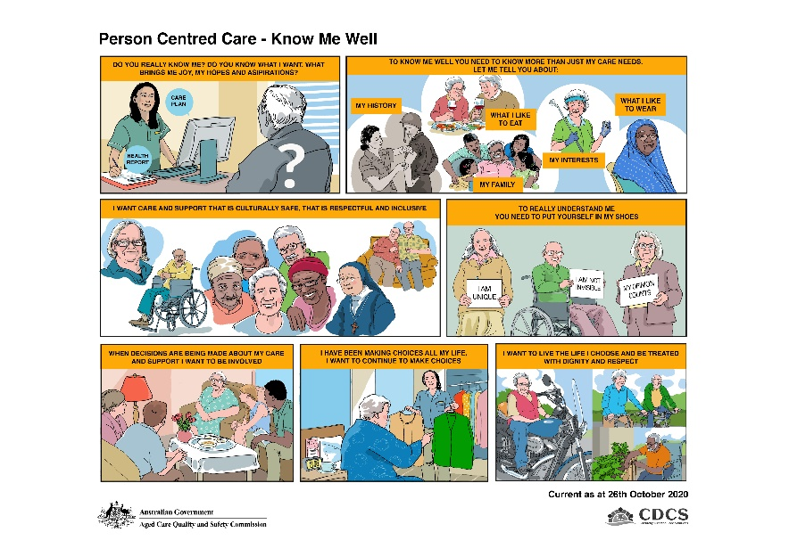
Frame 2: It is important to understand the person. Assessment, care planning and service delivery needs to take into consideration the person’s history, what they like to eat and drink, what they prefer to wear, any interests or hobbies they enjoy and family linkages that are important to them or groups they are a member of. Talk to each consumer and encourage them tell you their story. Explain to them why it is important for you to understand them and work with them to tailor their care and services.
Frame 3: Consumers want care that is safe, appropriate, respectful and inclusive. Service providers and their staff need to recognise and acknowledge the diverse needs of individuals to ensure an aged care system that provides respectful and inclusive aged care services regardless of the person’s background, life experiences, culture, body, gender or sexuality.
Frame 4: Consumers appreciate staff who take the time to understand their perspective and reality and who are empathetic. No consumer should need to hide who they are, be made to feel invisible or feel devalued. Taking the time to get to know each consumer will help to ensure they are comfortable and confident in sharing their background and experiences.
Frame 5: ‘Nothing about me without me’. Consumers of aged care services have the right to be included in discussions and consulted on decisions that directly affect them. Encourage your consumers to take part in the planning of their care and services.
Frame 6: Knowing a person well means that approaches to care and services can be tailored to the individual providing choices, activities, meals and daily life routines that suit each individual as much as possible. This helps to ensure that each consumers diverse life experiences and characteristics are recognised.
Frame 7: Consumers should be encouraged to be independent as far as possible. This will help to support the person to live the life they choose and can enable them to participate in life to the fullest. Support should recognise the concepts of Dignity of Risk and Informed Choice.

