COVID-19 Self Isolation – Help Stop the Spread
This storyboard is designed to illustrate how you self isolate if you have or are being tested for COVID-19. This is important to minimise the risk of passing on the virus to other people.
Frame 1: You may need to self isolate if you have travelled internationally or from interstate, follow your State or Commonwealth guidelines on this requirement.
Some people don’t have all the symptoms of the disease, but they can still be infectious. This means you will need to self isolate if you have been in close contact with a person who has been confirmed as having COVID-19.
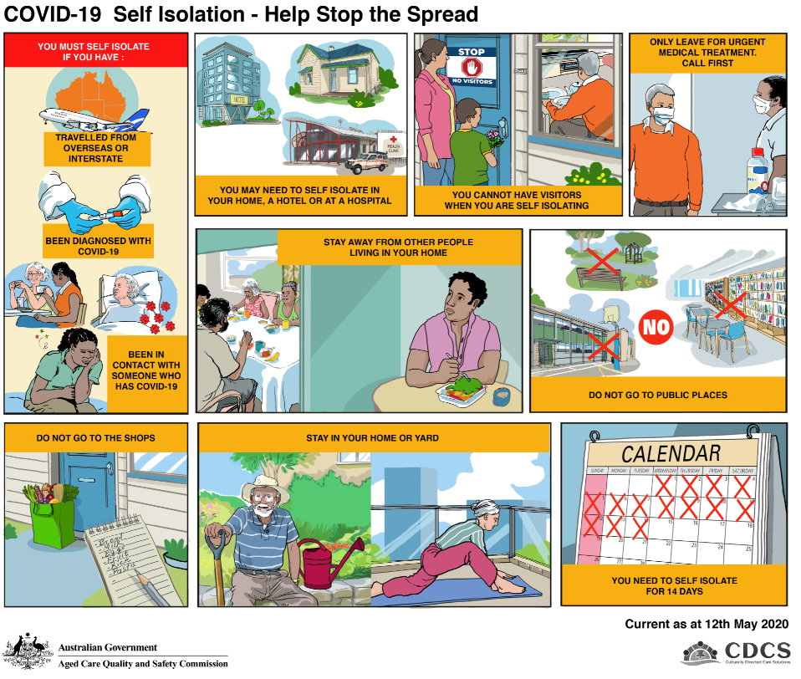
Close contact means that you have been in contact with the person in the 48 hours prior to them showing symptoms or being diagnosed with COVID-19.
You must also self isolate if you have COVID-19 symptoms but are waiting for confirmation of any testing.
Frame 2: You may be able to self isolate in your home. However, in some circumstances you will be required to self isolate in a hotel or medical setting.
Frame 3: You are not permitted to have visitors in your home during a period of self isolation, only people who normally reside in the home. If you are in a hotel you need to avoid contact with other guests and hotel staff. Instead, encourage family and friends to call or contact you using the phone or internet.
Frame 4: You should only leave the place you are self isolating in to access medical attention or in an emergency. You must always contact the health service prior to leaving and advise them that you are self isolating and seek and follow their advice which may include wearing a face mask when in public and in the clinic.
Frame 5: You may need to self isolate in your home where other people live. During the period of self isolation you should live separately from the others in your home. This includes sleeping and eating in a separate room, using separate eating implements and dishes and cleaning them separately. Where possible you should also use a dedicated, separate bathroom.
If you are well there is also no need for other people in the house to self isolate. If you become unwell with COVID-19 however they will need to self isolate as they would be considered close contacts of yours.
Frame 6 When in self isolation you are not able to visit any public buildings or open spaces. This includes visiting libraries, shopping centres, parks, work places, schools, child care centres and aged care facilities.
Frame 7: If you are required to self isolate you cannot leave to shop for groceries or visit the pharmacist to fill prescriptions. Instead, ask friends or family to shop for you and leave the grocery items at your front door, alternatively you can use online shopping services.
Frame 8: If you live in a private house, it is safe for you to go into your garden or courtyard. It is good for you to stay active and keep up routines as much as possible to manage boredom and stress.
Frame 9: As it can take up to 14 days for symptoms to appear after being in contact with someone with COVID-19 you will need to self isolate for the full 14 days.
Call your GP if you become unwell with COVID-19 symptoms during this period and seek advice. If you become seriously unwell or have difficulty breathing, call 000 immediately and advise them you are in self isolation and your symptoms.

