COVID-19 Social and Physical Distancing – Keeping Safe
This storyboard is designed to explain how social and physical distancing can help to slow the spread of viruses, such as COVID-19.
Frame 1: You can catch COVID-19 by being exposed to the virus when a person coughs or sneezes near you, or if you touch a surface like a door handle that has been touched by someone with the disease.
Frame 2: Because we don’t know who might be carrying the virus the best way to keep yourself safe is to practice Physical Distancing, sometimes also called Social Distancing.
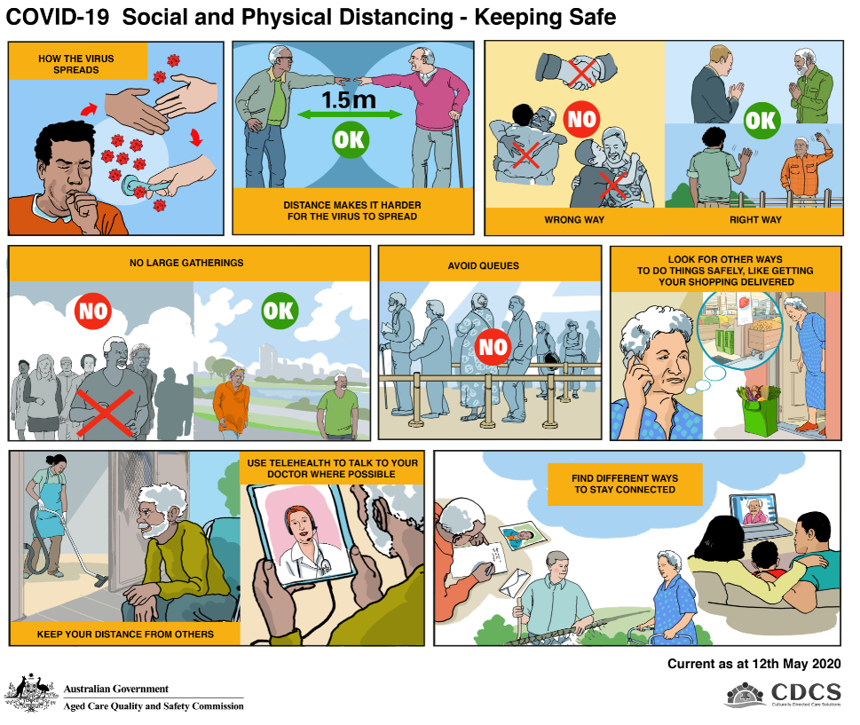
You should maintain a distance of 1.5m from other people – this is about the same distance as two arm lengths from another person.
Frame 3: You should refrain from activities such as shaking hands with others, hugging or kissing, especially with people outside your immediate household. If you are an older person this is really important because you are at a higher risk of catching the infection and becoming very ill.
Think of other ways to interact with people. You could wave, put your hand on your heart or bow.
Frame 4: Minimise the time you spend away from your home. Going out for exercise is good, but make sure that you do this away from areas where there is a lot of activity or other people.
Frame 5: You should also minimise the time you spend around other people. This include avoiding places where you need to queue up with lots of other people.
To help older people, many businesses have changed the way you can carry out some of your activities.
Frame 6 & 7: To reduce contact with other people, you can set up internet or phone banking so that you don’t have to go into a bank, you can order your groceries online and have them delivered to your door and you can speak to your Doctor over the internet using telehealth. Check what’s available in your area.
You also want to make sure that you are safe in your own home. If you have someone coming to clean your home or mow your lawn, maintain a safe distance from them at all times. Pay using direct debit rather than handling cash.
Frame 8: While it is important to physically distance from other people, you don’t want to miss out on keeping in touch with those people who mean a lot to you, your family and friends. To keep in touch, you could: catch up with your neighbour across the fence while keeping that 1.5m distance between you; write letters or speak with your family on the phone; catch up online using platforms such as Facebook, Facetime, Skype or WhatsApp.

