INCIDENT / INJURY/ NEAR MISS REPORT
To be completed for ALL incidents, injuries, accidents and near misses*
Regarding: (Please tick who this report is about) |  | Date (of report completion):
Client Employee Family/Carer Visitor Contractor Volunteer Other
1. Details of person involved in incident:
Surname: |  | Phone:
First Name: |  | Sex: Male Female Other Unknown
Address: |  | Date of Birth:
 |  | 1st Language:
2. Details of witnesses (if any):
1) Name: | Contact information e.g. phone, house number, address etc.
2) Name: | Contact information e.g. phone, house number, address etc.
3. Details of incident or accident:
Date: | Time of injury:
Activity engaged in:
Location of incident / accident:
Describe how and what happened: (please give full details & include a diagram, if appropriate. Use a separate sheet if necessary.
Please include car registration number if reporting a Motor Vehicle Accident):
* A near miss is an unplanned event that did not result in injury, illness, or damage – but had the potential to do so.
A report of a near miss (close call) creates an opportunity for identifying and removing hazardous conditions and work practices and preventing accidents.

4. Details of injury
Nature of any resulting injury / illness (e.g. burn, sprain, cut etc):
How the injury was sustained (e.g. fall, grabbed by a person etc.):
Location on body (e.g. back, right thumb, left arm etc) indicate where injury by shading in affected area | Written description of the impact of the incident, including any injuries or psychological impacts.
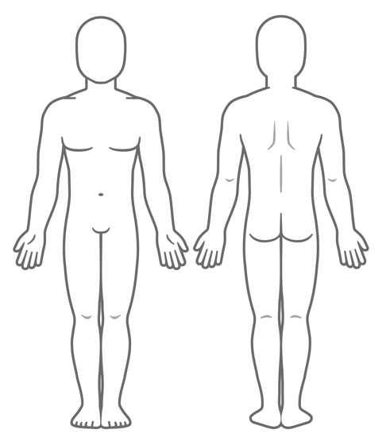
5. Treatment administered:
Did the person/s need medical assistance? Yes No
If yes – where did they go and who was the Medical provider?

First Aid Administered: Yes No | By who? (Print Name):  Signature:
Treatment (summary if relevant)

Referred to another service e.g. Clinic, General Practitioner, Hospital:

This page to be completed by the Senior Staff member
6. Did the injured person stop work:
Yes No If yes, state date: Time:
Outcome:
Treated by Doctor Lodged Workers Comp Claim Returned to alternative duties
Worksafe Authority notified Returned to normal duties
7. Incident or accident investigation
(Comments to include what caused or led to the accident/incident or near miss):
Name & Signature of Coordinator: Date:
8. Remedial actions (tick all that are applicable):
 | Document in the incident register and on hazard log. |  | Investigate safer alternatives |  | Improve communication / reporting procedures
 | Conduct task analysis & develop/review tasks/procedures |  | Improve personal protection |  | Improve security
 | Improve or make changes to the work environment. |  | Improve design / construction / guarding |  | Temporarily relocate employees involved
 | Review WHS policy/programs |  | Provide debriefing and/or counselling |  | Request Falls Prevention Assessment
 | Replace equipment / tools |  | Re-train staff involved |  | Request MSDS (Materials Safety Data Sheet)
 | Request maintenance |  | Develop and/or provide training |  | Other (specify)
What, in your own words, has been implemented or planned to prevent recurrence:
9. Remedial actions completed:
Signed: Title: Date:

